EBIT Run March 12-16, 2017

Written by: Amy Gall and Roshani Silwal

MOTIVATION AND GOALS

1. In a recent draft Astrophysics Research and Analysis (APRA) proposal written by members of Clemson/NIST and Harvard-Smithsonian Center for Astrophysics (CfA), a program is proposed to measure the n=2-1 line intensity ratio of Fe XXV and Fe XXVI using the NIST EBIT at multiple electron beam energies. Using a high resolution crystal spectrometer in tandem with a high purity germanium (HPGe) detector, the expected uncertainties of roughly 5% will allow us to compare measured values to the AtomDB model and provide the astrophysics community with highly accurate diagnostics. Fe is of particular interest due to its transition line energies above 6.4 keV, where future microcalorimeter satellite missions will have the highest resolution. The 2-3 day NIST EBIT measurement was intended to provide preliminary spectra of Fe XXV and Fe XXVI at one electron beam energy as proof of feasibility along with collection time and count rate estimates for the above mentioned proposal.

The first day of the experiment was dedicated to taking short (3 minute) x-ray measurements of various elements (both gas injection and MeVVA elements) at different electron beam energies for HPGe calibration purposes. Spectra were also collected with the crystal spectrometer to verify count rates and sin(θ) angle settings. On the second day, the electron beam energy was stationary (20 kV) as hours of three minute measurements were taken with both the HPGe detector and crystal spectrometer. Due to the limited (~120 eV) energy range of the crystal spectrometer (housed with a Ge 220 crystal), measurements were taken at two angle settings to detect the n=2-1 transition in both charge states (Fe XXV and XXVI). The three minute measurements were added (for crystal spectrometer) to improve the signal and obtain a clear spectrum.

2. High Z elements are of significant interest, both theoretically and experimentally, given their sensitivity to relativistic and QED effects. We are interested in the measurement of transitions of ytterbium N-shell ions (Ni-like through K-like) and the M-shell (Na-like through Ar-like) in continuation of similar measurement in November for Rb-like through Ni-like ions. With this measurement, we continue to provide critical spectroscopic for different research communities. The measurement was performed in the extreme ultraviolet (EUV) region using a flat-field grazing incidence EUV spectrometer with a liquid nitrogen cooled CCD.

EXPERIMENTAL SETUP

Three instruments were used to collect data during the run. The measured spectral regions include EUV and x-ray.

*EUV Spectrometer [1]:*

For the first two days of the run, the primary measurements of interest lie in the x-ray region; however EUV spectra were taken simultaneously throughout the week. Details on the EUV CCD are listed in Table 1.

Table 1: EUV CCD Details

|  |  |  |  |  |  |
| --- | --- | --- | --- | --- | --- |
| **Instrument** | **Pixel array size** | **Pixel Size (µm)** | **Software** | **Operation Temperature** | **Readout Rate** |
| Princeton Instruments CCD | 2048 x 512 | 13 | Winspec | -120 °C | 100 kHz |

For the entire run, the EUV CCD temperature was locked at −120 °C, the readout rate was 100 kHz to provide the lowest readout noise, and the controller gain was set to 3 in order to measure low-level intensity signals and reduce noise. The spectral images (2048×512 pixels), registered with the help of the CCD, were integrated along the y-axis, so that the resulting image is 1D-image 2048×1 pixel. The pressure readings for the ion-pump, grating chamber and cathode gauge of mirror and grating chamber for the EUV mirror are listed in Table *2*.

Table 2: EUV Pressure Settings

|  |  |
| --- | --- |
| Mirror Chamber Cathode (Torr) | 4.80E-09 |
| Grating Chamber Cathode (Torr) | 1.30E-08 |
| Mirror Chamber (Torr) | 3.80E-09 |
| Grating Chamber (Torr) | 1.70E-08 |

In order to prevent the stray light from pumps and gauges to reach the CCD chip, the ion pump for the grating chamber and the cold cathode gauges for both mirror and grating chambers were turned off during the EBIT operation. The ion pump for the mirror chamber was operated all the time with typical pressure reading of around 3.8× 10−9 Torr during EBIT runs. The EUV vacuum is separated from the EBIT vacuum by a black gate valve which is closed at all times except during data acquisition. There is another gate valve between the mirror UHV chamber and grating UHV chamber which is open throughout the measurements.

The table below lists the range of EUV wavelengths at different positions.

Table 3: EUV Spectral Range At Given Position

|  |  |
| --- | --- |
| **Position** | **Range (nm)** |
| 0.144” (+) | 2.7 - 13.3 |
| 0.994” (-) | 4 - 19.9 |
| 0.675” (-) | 7.8 - 25.8 |

*Crystal Spectrometer*:

The Johann-type crystal spectrometer has a resolution better than 2 eV at 3 keV. The spectrometer vacuum is separated from the EBIT vacuum by a 230 μm thick Beryllium window. Currently there is a **Ge (220)** crystal installed in the spectrometer is which has a 2d spacing of 4 and covers a spectral range of 3.479 to 7.200 keV, as shown in the image below.

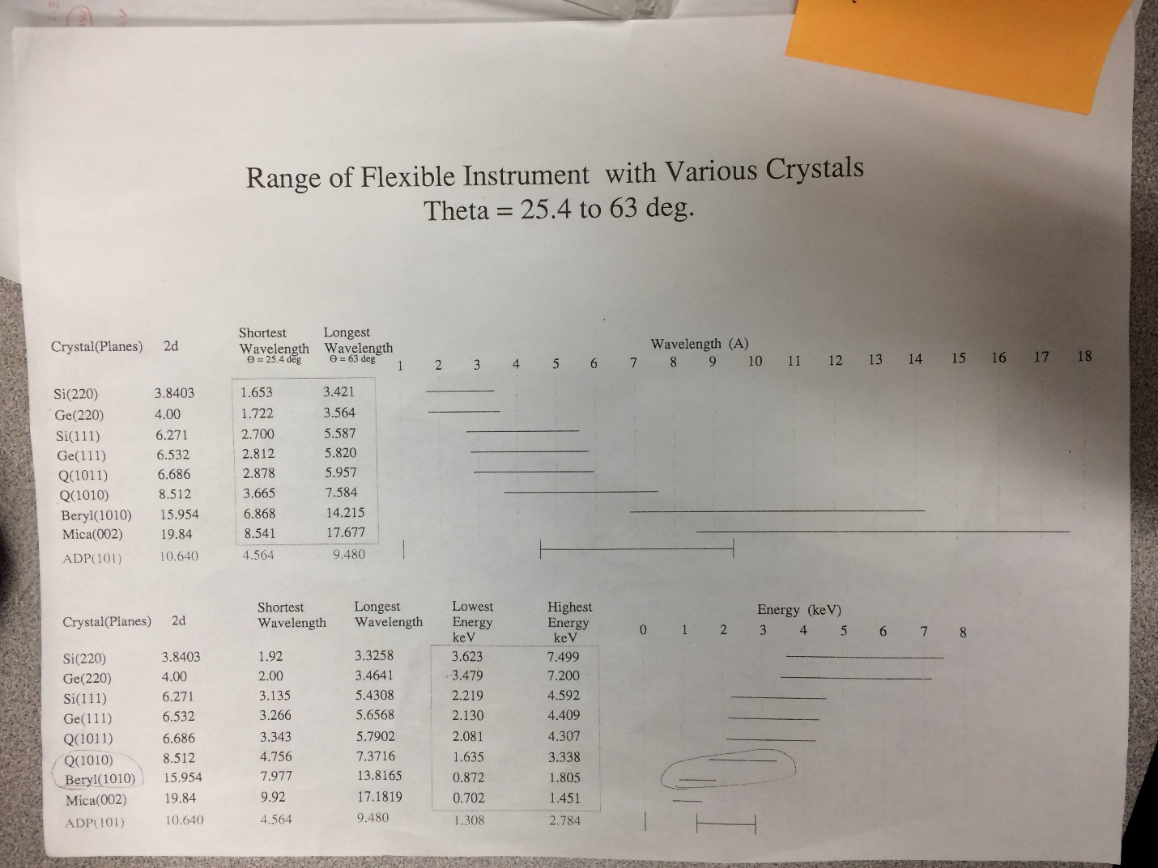

Details of the x-ray CCD used to take measurements are provided in Table 4 . The CCD was cooled to -75 °C with a chilled water setup, the readout rate was 50 KHz with a 4x amplification, and the image was saved in .sif and .fits format. The camera was kept at vacuum of 2.6 x10-3 torr and the data was collected using the single data acquisition mode. During the data acquisition, the gauge was turned off to enhance the signal to noise ratio. The hardware temperature is maintained by the camera software ANDOR Solis.

Table 4

|  |  |  |  |  |  |  |
| --- | --- | --- | --- | --- | --- | --- |
| **Instrument** | **Pixel Array Size** | **Pixel Size (µm)** | **Software** | **Operation Temperature** | **Readout Rate** | **Spectrometer Pressure** |
| Andor ikon-L CCD | 2048 x 2048 | 13.5 | Andor Solis | -75°C | 50 kHz | 2.60E-03  torr |

*Germanium Detector*:

A Canberra LN2 cooled Ge-detector was used in addition to the Crystal Spectrometer to take x-ray measurements. . The HPGe detector was separated from the EBIT through a 340 nm thick aluminum-coated polymer window. Pro-X software was used to control the detector.

*MEVVA [2]*:

Metal vapor vacuum arc (MEVVA) is a high current ion source containing eight different cathodes used to produce beams of metal ions for injection into the trap region of the EBIT. The cathodes are individually selectable with the control electronics and do not require moving components in vacuum. The sequence for ion production starts with an optical pulse that is received by the trigger generator. The generator then triggers the pressurized spark gap switch. This switch rapidly conducts the charge through a damping resistor and a 10m RG-8 coaxial cable, used as a high voltage cable, forming a high voltage pulse that arrives at the radio frequency (rf) tight enclosure at the MeVVA head assembly. This assembly has two sections, an upper stage, which is the rf-tight RG-8 cable interface, and a lower section which houses the high voltage vacuum feed-through flange. When the high voltage pulse reaches the tip of the cathode sample material in vacuum, it jumps a small gap to the anode which allows the arc discharge to occur. Both the cathode and anode grids are floated up to an applied bias voltage (20 kV in this case) relative to the extractor grid which remains at chamber ground. Hence ions are extracted from the arc plasma and accelerated toward the EBIT system with a kinetic energy established by the bias voltage. The cathodes are selected manually in the MEVVA control box situated in the high voltage room. The total number of MEVVA shots was recorded during the end of every run and number of shots for each cathode was recorded before switching to other cathode. Before every run, the number of shots for the cathode was reset to zero. The electron beam current was always optimized for the chosen energy.

MEVVA Cathodes: A - W; B - Bi, C - Mo; D - Y; E - Zr; F - Fe; G - Nb; H – Yb

EBIT:

The EBIT parameters recorded in Table 5 were taken in the morning of the first day of measurements (3/12/17).

Table 5:

|  |  |
| --- | --- |
| EBIT settings 03/12/17 | |
| Beam line Pressure (Torr) |  |
| e- gun pressure (Torr) | 3.60E-10 |
| crystal spectrometer (Torr) | 3.30E-07 |
| Mevva section (Torr) | 2.00E-08 |
| Big 3 (Torr) | 2.10E-09 |
| Bender #1 (Torr) | 5.20E-09 |
| Bender #2 (Torr) | 5.30E-09 |
| Mirror Chamber; Cathode (Torr) | 3.80E-09 |
| Grating Chamber; Cathode (Torr) | 1.30E-08 |
| Mirror Chamber (Torr) | 1.90E-09 |
| Grating Chamber (Torr) | 1.50E-08 |
| Gas injection pressure (Torr) | 2.19E-05 |
| Super Magnet resistance (Ohm) |  |
|  |  |
| Focus (v) | 9 |
| suppressor (v) | 560 |
| einzel lens (v) | 1250 |
| extractor (v) | 2170 |
| Transition (v) | 5.38 |
| filament (v) | 6.3 |
| filament (amp) | 0.487 |
| TC1 (collector exhaust) °F | 296.7/-302 when anode on |
| UDT (v) | 260 |
| LDT (v) | 500 |
| MDT (V) | 400 |
| Collector magnet voltage (V) | 5 |
| collector magnet current (A) | 0.5532 |
| SC magnet current (A) | 147.8 |
| Bucking coil voltage (v) | 0.5466 |
| snout (μA) | 19.75 |
| collector voltage (2kV) | 2 |

EBIT Run Day 1 (03/12/17):

The EBIT was cooled to LN2 temperature on 03/11 and 03/12/17. The EBIT was filled using a LHe dewar and cooled to LHe temperature on the morning of 3/12/17 (~9am) and the resistance of the superconducting magnet RSCM quickly fell close to 0 Ω. Once the lower and upper EBIT chambers were filled with LHe, the EBIT was turned on.

Using list of elements, line energies, and electron beam energies outlined in Figure 1 (by Dr. Takacs), we planned to make the listed measurements with the HPGe detector for calibration. The previous day, while training the MeVVA we were unable to obtain a signal for Bi. As a result, we were unable to collect Bi data.

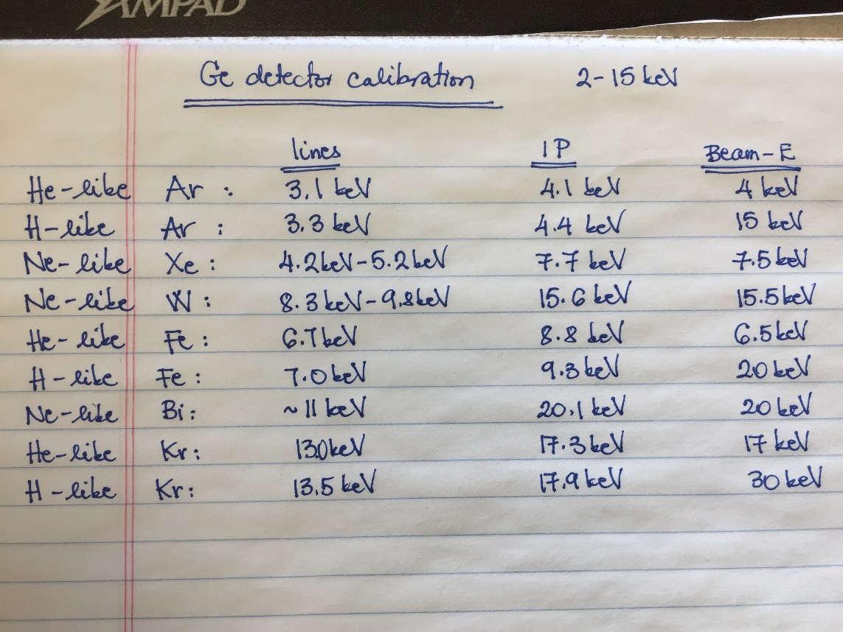

Figure 1: Planned HPGe measurements

Once the EBIT was running, we injected Ar into the EBIT using the gas injection system and monitored the live output spectra produced by the HPGe detector software. Instantly we noticed that the detector cut-off energy was shifted. Previously the cut-off was around 1-2 keV, and on 3/12 it was around 5 keV. After adjusting many settings, we realized the “Fast Disc. Shape” was set to “normal” instead of “low energy”. Once we set it back to low energy, the cut-off shifted back to a lower energy. We collected Ar spectra with a 3 and 5 sec cooking time with and without injection as indicated in Table 6.

While turning on the electron beam, we made sure that the snout current was never above 15 mA. Voltages were set through Labview vertex in the EBIT control room (entered via the VI). All other values were set manually in the control panel. Several EBIT parameters chosen for the experiment are listed in Table 5. The vertex for each shield voltage was set using a conversion factor of 2.9197.

Table 6

|  |  |  |  |  |  |  |  |  |  |  |  |  |  |
| --- | --- | --- | --- | --- | --- | --- | --- | --- | --- | --- | --- | --- | --- |
|  |  |  | file name | | |  |  |  |  | Collection time (s) | | |  |
| Element | sin x | encoder | Crystal | EUV | Ge | Shield voltage (kV) | Labview setting | Gas injection pressure (Torr) | Electron beam current (mA) | Crystal (s) | Ge (s) | EUV (s) | cook time (s) |
| Ar | - | - | - | EUV001 | X001 | 3.98 | 1.444 | 2.15E-05 | 150 | - | 300 | 300 | 3 |
| Ar | 0.4452 | -102860 | - | EUV002 | X002 | 15.16 | 5.415 | 2.13E-05 | 150 | - | 300 | 300 | 3 |
| Fe | - | - | - | EUV003 | X003 | 7.4 |  | - | 150 | - | 74 |  | 5 |
| Ar (no gas) | - | - | - | - | X004 | 20 |  | - | 150 | - | 180 |  | 5 |
| Ar(no gas) | - |  | - | - | X005 | 20 |  | - | 150 | - | 180 |  | 5 |

Next we injected Fe using the MeVVA. We optimized our signal by monitoring the counts per second (cps) output from the HPGe detector and adjusting the delay and MeVVA voltage to match the shield +MDT voltage. Once we maximized our counts to ~65cps, we took measurements according to Table 7.

Crystal Angle:

From the NIST database (Image below), the strong He-like n=2-1 transition energies are between 6636 and 6700 eV. Using this we set the crystal angle to 0.4647 (, with 2d = 4 and choosing E = 6670 eV= 1.858833544 Å, then ). For the H-like transition, the n=2-1 energies are at 6973 and 6951 eV, so selecting a value in between (6962 eV), we calculated an angle of 0.4452.

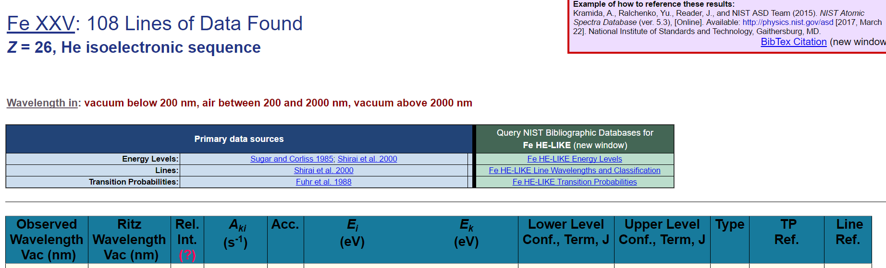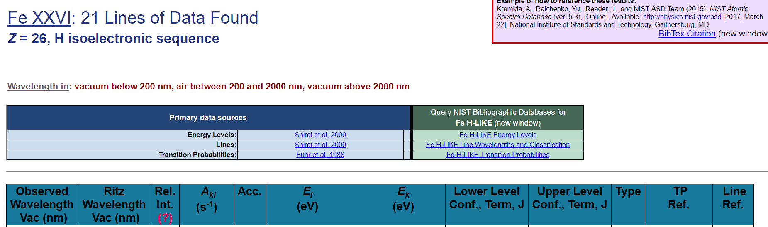

|  |  |  |  |  |  |  |  |  |  |  |  |
| --- | --- | --- | --- | --- | --- | --- | --- | --- | --- | --- | --- |
|  |  | file name  Table 7 | | |  |  |  | Collection time (s) | | |  |
| Element | sin x | Crystal | EUV | Ge | Shield Voltage (kV) | Labview setting | Electron beam current (mA) | Crystal (s) | Ge (s) | EUV (s) | cooking time (s) |
| Fe | 0.4452 | SX006 | EUV006 | X006 | 20 | 7.155 | 150 | 180 | 180 | 300 | 5 |
| Fe | 0.4452 | SX006_1 | EUV006_1 | X006_1 | 20 | 7.155 | 150 | 180 | 180 | 180 | 5 |
| Fe | 0.4452 | SX006_2 | EUV006_2 | X006_2 | 20 | 7.155 | 150 | 180 | 180 | 180 | 5 |
| Fe | 0.4452 | SX006_3 | EUV006_3 | X006_3 | 20 | 7.155 | 150 | 180 | 180 | 180 | 5 |
| Fe | 0.4452 | SX006_4 | EUV006_4 | X006_4 | 20 | 7.155 | 150 | 180 | 180 | 180 | 5 |
| Fe | 0.4452 | SX006_5 | EUV006_5 | X006_5 | 20 | 7.155 | 150 | 180 | 180 | 180 | 5 |
| Fe | 0.4452 | SX006_6 | EUV006_6 | X006_6 | 20 | 7.155 | 150 | 180 | 180 | 180 | 5 |
| Fe | 0.4452 | SX006_7 | EUV006_7 | X006_7 | 20 | 7.155 | 150 | 180 | 180 | 180 | 5 |
| Fe | 0.4452 | SX006_8 | EUV006_8 | X006_8 | 20 | 7.155 | 150 | 180 | 180 | 180 | 5 |
| Fe | 0.4452 | SX006_9 | EUV006_9 | X006_9 | 20 | 7.155 | 150 | 180 | 180 | 180 | 5 |
| Fe | 0.4452 | SX006_10 | - | X006_10 | 20 | 7.155 | 150 | 180 | 180 | 180 | 5 |
| Fe | 0.4452 | SX006_11 | EUV006_11 | X006_11 | 20 | 7.155 | 150 | 180 | 180 | 180 | 5 |
| Fe | 0.4452 | SX006_12 | EUV006_12 | X006_12 | 20 | 7.155 | 150 | 180 | 180 | 180 | 5 |
| Fe | 0.4452 | SX006_13 | EUV006_13 | X006_13 | 20 | 7.155 | 150 | 180 | 180 | 180 | 5 |
| Fe | 0.4452 | SX006_14 | EUV006_14 | X006_14 | 20 | 7.155 | 150 | 180 | 180 | 180 | 5 |
| Fe | 0.4452 | SX006_15 | EUV006_15 | X006_15 | 20 | 7.155 | 150 | 180 | 180 | 180 | 5 |
| Fe | 0.4452 | SX006_16 | EUV006_16 | X006_16 | 20 | 7.155 | 150 | 180 | 180 | 180 | 5 |
| Fe | 0.4452 | SX006_17 | EUV006_17 | X006_17 | 20 | 7.155 | 150 | 180 | 180 | 180 | 5 |
| Fe | 0.4452 | SX006_18 | EUV006_18 | X006_18 | 20 | 7.155 | 150 | 180 | 180 | 180 | 5 |
| Fe | 0.4452 | SX006_19 | EUV006_19 | X006_19 | 20 | 7.155 | 150 | 180 | 180 | 180 | 5 |
| Fe | 0.4452 | SX006_20 | EUV006_20 | X006_20 | 20 | 7.155 | 150 | 180 | 180 | 180 | 5 |
| Fe | 0.4452 | SX006_21 | EUV006_21 | X006_21 | 20 | 7.155 | 150 | 180 | 180 | 180 | 5 |
| Fe | 0.4452 | SX006_22 | EUV006_22 | X006_22 | 20 | 7.155 | 150 | 180 | 180 | 180 | 5 |
| Fe | 0.4452 | SX006_23 | EUV006_23 | X006_23 | 20 | 7.155 | 150 | 180 | 180 | 180 | 5 |
| Fe | 0.4452 | SX006_24 | EUV006_24 | X006_24 | 20 | 7.155 | 150 | 180 | 180 | 180 | 5 |
| Fe | 0.4452 | SX006_25 | EUV006_25 | X006_25 | 20 | 7.155 | 150 | 180 | 180 | 180 | 5 |
| Fe | 0.4452 | SX006_26_1 | EUV006_26 | X006_26 | 20 | 7.155 | 150 | 180 | 180 | 180 | 5 |
| Fe | 0.4452 | SX006_27 | EUV006_27 | X006_27 | 20 | 7.155 | 150 | 180 | 180 | 180 | 5 |
| Fe | 0.4452 | SX006_28 | EUV006_28 | X006_28 | 20 | 7.155 | 150 | 180 | 180 | 180 | 5 |
| Fe | 0.4452 | SX006_29 | EUV006_29 | X006_29 | 20 | 7.155 | 150 | 180 | 180 | 180 | 5 |
| Fe | 0.4452 | SX006_30 | EUV006_30 | X006_30 | 20 | 7.155 | 150 | 180 | 180 | 180 | 5 |
| Fe | 0.4452 | SX006_31 | EUV006_31 | X006_31 | 20 | 7.155 | 150 | 180 | 180 | 180 | 5 |
| Fe | 0.4452 | SX006_32 | EUV006_32 | X006_32 | 20 | 7.155 | 150 | 180 | 180 | 180 | 5 |
| Fe | 0.4452 | SX006_33 | EUV006_33 | X006_33 | 20 | 7.155 | 150 | 180 | 180 | 180 | 5 |
| Fe | 0.4647 | SX007 | EUV007 | X007 | 6.53 | 2.3465 | 130 | 180 | 180 | 180 | 5 |
| Fe | 0.4647 | SX007_1 | EUV007_1 | X007_1 | 6.53 | 2.3465 | 130 | 180 | 180 | 180 | 5 |
| Fe | 0.4647 | SX007_2 | EUV007_2 | X007_2 | 6.53 | 2.3465 | 130 | 180 | 180 | 180 | 5 |
| Fe | 0.4647 | SX007_3 | EUV007_3 | X007_3 | 6.53 | 2.3465 | 130 | 180 | 180 | 180 | 5 |
| Fe | 0.4647 | SX007_4 | EUV007_4 | X007_4 | 6.53 | 2.3465 | 130 | 180 | 180 | 180 | 5 |
| Fe | 0.4647 | SX008 | EUV008 | X008 | 8.5 | 3.0544 | 130 | 180 | 180 | 180 | 5 |
| Fe | 0.4647 | SX008_1 | EUV008_1 | X008_1 | 8.5 | 3.0544 | 130 | 180 | 180 | 180 | 5 |
| Fe | 0.4647 | SX008_2 | EUV008_2 | X008_2 | 8.5 | 3.0544 | 130 | 180 | 180 | 180 | 5 |
| Fe | 0.4647 | SX008_3 | EUV008_3 | X008_3 | 8.5 | 3.0544 | 130 | 180 | 180 | 180 | 5 |
| Fe | 0.4647 | SX008_4 | - | X008_4 | 8.5 | 3.0544 | 130 | 180 | 180 | 180 | 5 |
| Fe | 0.4647 | SX008_5 | EUV008_5 | X008_5 | 8.5 | 3.0544 | 130 | 180 | 180 | 180 | 5 |
| Fe | 0.4647 | SX008_6 | EUV008_6 | X008_6 | 8.5 | 3.0544 | 130 | 180 | 180 | 180 | 5 |
| Fe | 0.4647 | SX008_7 | EUV008_7 | X008_7 | 8.5 | 3.0544 | 130 | 180 | 180 | 180 | 5 |
| Fe | 0.4647 | SX008_8 | EUV008_8 | X008_8 | 8.5 | 3.0544 | 130 | 180 | 180 | 180 | 5 |
| Fe | 0.4647 | SX008_9 | EUV008_9 | X008_9 | 8.5 | 3.0544 | 130 | 180 | 180 | 180 | 5 |
| Fe | 0.4647 | SX008_10 | EUV008_10 | X008_10 | 8.5 | 3.0544 | 130 | 180 | 180 | 180 | 5 |
| Fe | 0.4647 | SX008_11 | EUV008_11 | X008_11 | 8.5 | 3.0544 | 130 | 180 | 180 | 180 | 5 |
| Fe | 0.4647 | SX008_12 | EUV008_12 | X008_12 | 8.5 | 3.0544 | 130 | 180 | 180 | 180 | 5 |
| Fe | 0.4647 | SX008_13 | EUV008_13 | X008_13 | 8.5 | 3.0544 | 130 | 180 | 180 | 180 | 5 |
| Fe | 0.4647 | SX008_14 | EUV008_14 | X008_14 | 8.5 | 3.0544 | 130 | 180 | 180 | 180 | 5 |
| Fe | 0.4647 | SX008_15 | EUV008_15 | X008_15 | 8.5 | 3.0544 | 130 | 180 | 180 | 180 | 5 |
| Fe | 0.4647 | SX008_16 | EUV008_16 | X008_16 | 8.5 | 3.0544 | 130 | 180 | 180 | 180 | 5 |
| Fe | 0.4647 | SX008_17 | EUV008_17 | X008_17 | 8.5 | 3.0544 | 130 | 180 | 180 | 180 | 5 |
| Fe | 0.4647 | SX008_18 | EUV008_18 | X008_18 | 8.5 | 3.0544 | 130 | 180 | 180 | 180 | 5 |
| Fe | 0.4647 | SX008_19 | EUV008_19 | X008_19 | 8.5 | 3.0544 | 130 | 180 | 180 | 180 | 5 |
| Fe | 0.4647 | SX008_20 | EUV008_20 | X008_20 | 8.5 | 3.0544 | 130 | 180 | 180 | 180 | 5 |

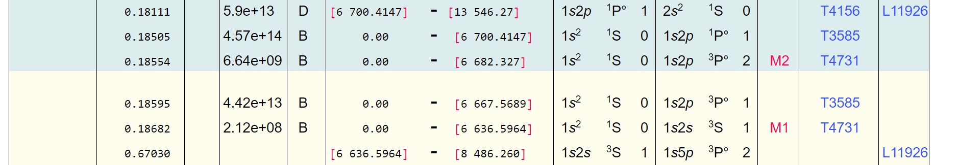





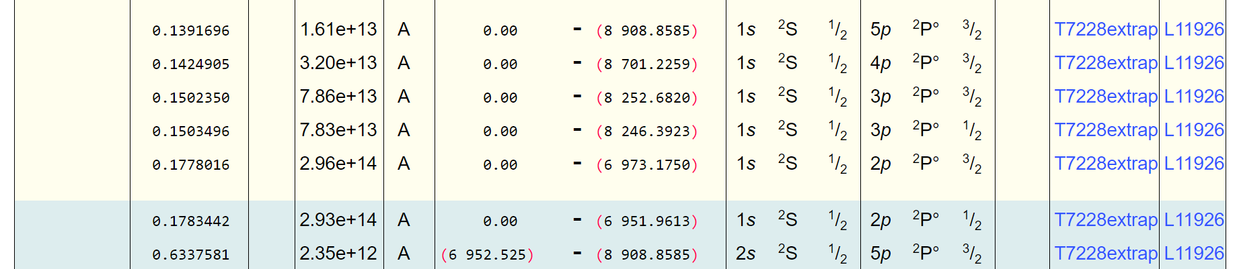

While collecting the data, we simultaneously did a rough cosmic ray removal, summing of the spectra, and smoothing in IGOR to see if we had high enough counts. The sx006 series for H-like Fe at a shield voltage of 20 kV is shown in Figure 2, series sx007 for He-like Fe at a shield voltage of 6.53 kV is shown in Figure 3, and sx008 for the He-like charge state taken at a shield voltage setting of 8.5 kV is shown in Figure 4.

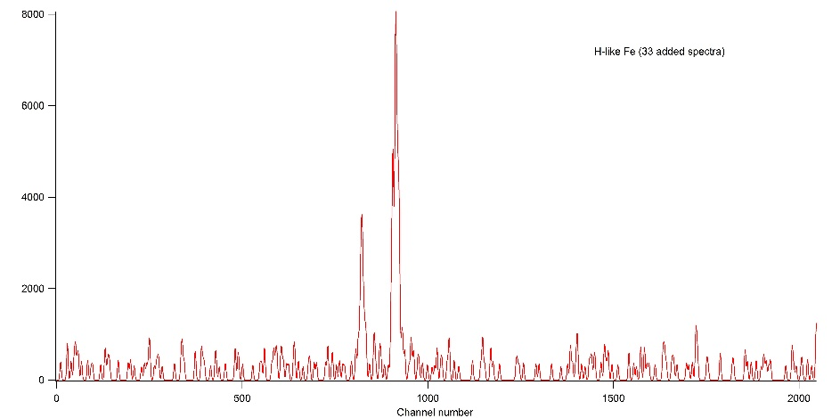

Figure 2: SX_006, 20 kV

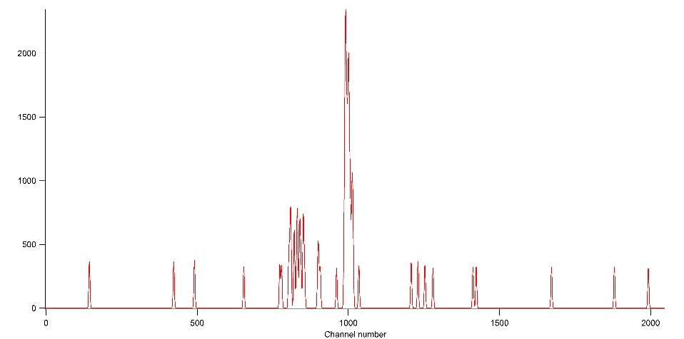

Figure 3: SX_007, 6.53 kV

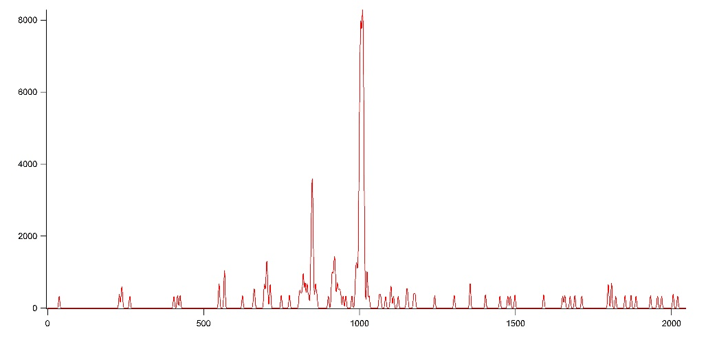

Figure 4:SX_008, 8.5 kV

EBIT Run Day 2 (03/13/17):

We followed the same starting procedure as Day 1, by cooling the EBIT to LHe. EBIT settings are given in Table 5. Since the overall goal is to measure line intensity ratios at the same energy, the plan for the day was to measure the n=2-1 transition in H and He-like Fe at the same electron beam energy (shield voltage).

In the previous day’s He-like Fe added spectrum (Figure 4), we noticed some of the peaks of interest were close to the edge of the spectrum, so we decided to slightly move the crystal to ensure we would measure all of the peaks of interest. Choosing a central energy of 6660 eV, we calculated the crystal spectrometer angle to be 0.4654 for He-like Fe.

We again took hours of 3 minute measurements using the crystal spectrometer, HPGe detector and EUV detector. As detailed in Table 8, 45 measurements were taken at a crystal angle of 0.4654 for He-like Fe and 50, 3 minute measurements were taken at an angle of 0.4452 for H-like Fe.

Table 8

|  |  |  |  |  |  |  |  |  |  |  |  |  |
| --- | --- | --- | --- | --- | --- | --- | --- | --- | --- | --- | --- | --- |
|  |  |  | File Name | | |  |  |  | Collection time | | |  |
| Element | sin x | encoder | Crystal | EUV | Ge | Shield Voltage (kV) | Labview setting | Electron beam current (mA) | Crystal (s) | Ge (s) | EUV (s) | Cook  Time (s) |
| Fe | 0.4654 | -91830 | SX009 | EUV009 | X009 | 20 | 7.155 | 145 | 180 | 180 | 180 | 5 |
| Fe | 0.4654 | -91830 | SX009_1 | EUV009_1 | X009_1 | 20 | 7.155 | 145 | 180 | 180 | 180 | 5 |
| Fe | 0.4654 | -91830 | SX009_2 | EUV009_2 | X009_2 | 20 | 7.155 | 145 | 180 | 180 | 180 | 5 |
| Fe | 0.4654 | -91830 | SX009_3 | EUV009_3 | X009_3 | 20 | 7.155 | 145 | 180 | 180 | 180 | 5 |
| Fe | 0.4654 | -91830 | SX009_4 | EUV009_4 | X009_4 | 20 | 7.155 | 145 | 180 | 180 | 180 | 5 |
| Fe | 0.4654 | -91830 | SX009_5 | EUV009_5 | X009_5 | 20 | 7.155 | 145 | 180 | 180 | 180 | 5 |
| Fe | 0.4654 | -91830 | SX009_6 | EUV009_6 | X009_6 | 20 | 7.155 | 145 | 180 | 180 | 180 | 5 |
| Fe | 0.4654 | -91830 |  | EUV009_7 | X009_7 | 20 | 7.155 | 145 | 180 | 180 | 180 | 5 |
| Fe | 0.4654 | -91830 | SX009_8 | EUV009_8 | X009_8 | 20 | 7.155 | 145 | 180 | 180 | 180 | 5 |
| Fe | 0.4654 | -91830 | SX009_9 | EUV009_9 | X009_9 | 20 | 7.155 | 145 | 180 | 180 | 180 | 5 |
| Fe | 0.4654 | -91830 | SX009_10 | EUV009_10 | X009_10 | 20 | 7.155 | 145 | 180 | 180 | 180 | 5 |
| Fe | 0.4654 | -91830 | SX009_11 | EUV009_11 | X009_11 | 20 | 7.155 | 145 | 180 | 180 | 180 | 5 |
| Fe | 0.4654 | -91830 | SX009_12 | EUV009_12 | X009_12 | 20 | 7.155 | 145 | 180 | 180 | 180 | 5 |
| Fe | 0.4654 | -91830 | SX009_13 | EUV009_13 | X009_13 | 20 | 7.155 | 145 | 180 | 180 | 180 | 5 |
| Fe | 0.4654 | -91830 | SX009_14 | EUV009_14 | X009_14 | 20 | 7.155 | 145 | 180 | 180 | 180 | 5 |
| Fe | 0.4654 | -91830 | SX009_15 | EUV009_15 | X009_15 | 20 | 7.155 | 145 | 180 | 180 | 180 | 5 |
| Fe | 0.4654 | -91830 | SX009_16 | EUV009_16 | X009_16 | 20 | 7.155 | 145 | 180 | 180 | 180 | 5 |
| Fe | 0.4654 | -91830 | SX009_17 | EUV009_17 | X009_17 | 20 | 7.155 | 145 | 180 | 180 | 180 | 5 |
| Fe | 0.4654 | -91830 | SX009_18 | EUV009_18 | X009_18 | 20 | 7.155 | 145 | 180 | 180 | 180 | 5 |
| Fe | 0.4654 | -91830 | SX009_19 | EUV009_19 | X009_19 | 20 | 7.155 | 145 | 180 | 180 | 180 | 5 |
| Fe | 0.4654 | -91830 | SX009_20 | EUV009_20 | X009_20 | 20 | 7.155 | 145 | 180 | 180 | 180 | 5 |
| Fe | 0.4654 | -91830 | SX009_21 | EUV009_21 | X009_21 | 20 | 7.155 | 145 | 180 | 180 | 180 | 5 |
| Fe | 0.4654 | -91830 | SX009_22 | EUV009_22 | X009_22 | 20 | 7.155 | 145 | 180 | 180 | 180 | 5 |
| Fe | 0.4654 | -91830 | SX009_23 | EUV009_23 | X009_23 | 20 | 7.155 | 145 | 180 | 180 | 180 | 5 |
| Fe | 0.4654 | -91830 | SX009_24 | EUV009_24 | X009_24 | 20 | 7.155 | 145 | 180 | 180 | 180 | 5 |
| Fe | 0.4654 | -91830 | SX009_25 | EUV009_25 | X009_25 | 20 | 7.155 | 145 | 180 | 180 | 180 | 5 |
| Fe | 0.4654 | -91830 | SX009_26 | EUV009_26 | X009_26 | 20 | 7.155 | 145 | 180 | 180 | 180 | 5 |
| Fe | 0.4654 | -91830 | SX009_27 | EUV009_27 | X009_27 | 20 | 7.155 | 145 | 180 | 180 | 180 | 5 |
| Fe | 0.4654 | -91830 | SX009_28 | EUV009_28 | X009_28 | 20 | 7.155 | 145 | 180 | 180 | 180 | 5 |
| Fe | 0.4654 | -91830 | SX009_29 | EUV009_29 | X009_29 | 20 | 7.155 | 145 | 180 | 180 | 180 | 5 |
| Fe | 0.4654 | -91830 | SX009_30 | EUV009_30 | X009_30 | 20 | 7.155 | 145 | 180 | 180 | 180 | 5 |
| Fe | 0.4654 | -91830 | SX009_31 | EUV009_31 | X009_31 | 20 | 7.155 | 145 | 180 | 180 | 180 | 5 |
| Fe | 0.4654 | -91830 | SX009_32 | EUV009_32 | X009_32 | 20 | 7.155 | 145 | 180 | 180 | 180 | 5 |
| Fe | 0.4654 | -91830 | SX009_33 | EUV009_33 | X009_33 | 20 | 7.155 | 145 | 180 | 180 | 180 | 5 |
| Fe | 0.4654 | -91830 | SX009_34 | EUV009_34 | X009_34 | 20 | 7.155 | 145 | 180 | 180 | 180 | 5 |
| Fe | 0.4654 | -91830 | SX009_35 | EUV009_35 | X009_35 | 20 | 7.155 | 145 | 180 | 180 | 180 | 5 |
| Fe | 0.4654 | -91830 | SX009_36 | EUV009_36 | X009_36 | 20 | 7.155 | 145 | 180 | 180 | 180 | 5 |
| Fe | 0.4654 | -91830 | SX009_37 | EUV009_37 | X009_37 | 20 | 7.155 | 145 | 180 | 180 | 180 | 5 |
| Fe | 0.4654 | -91830 | SX009_38 | EUV009_38 | X009_38 | 20 | 7.155 | 145 | 180 | 180 | 180 | 5 |
| Fe | 0.4654 | -91830 | SX009_39 | EUV009_39 | X009_39 | 20 | 7.155 | 145 | 180 | 180 | 180 | 5 |
| Fe | 0.4654 | -91830 | SX009_40 | EUV009_40 | X009_40 | 20 | 7.155 | 145 | 180 | 180 | 180 | 5 |
| Fe | 0.4654 | -91830 | SX009_41 | EUV009_41 | X009_41 | 20 | 7.155 | 145 | 180 | 180 | 180 | 5 |
| Fe | 0.4654 | -91830 | SX009_42 | EUV009_42 | X009_42 | 20 | 7.155 | 145 | 180 | 180 | 180 | 5 |
| Fe | 0.4654 | -91830 | SX009_43 | EUV009_43 | X009_43 | 20 | 7.155 | 145 | 180 | 180 | 180 | 5 |
| Fe | 0.4654 | -91830 | SX009_44 | EUV009_44 | X009_44 | 20 | 7.155 | 145 | 180 | 180 | 180 | 5 |
| Bg | 0.4654 | -91830 |  |  | X | 20 | 7.155 | 145 | 180 | 180 | 180 | nocook |
| Fe | 0.4452 | -102705 | SX010 | EUV010 | X010 | 20 | 7.155 | 145 | 180 | 180 | 180 | 5 |
| Fe | 0.4452 | -102705 | SX010_1 | EUV010_1 | X010_1 | 20 | 7.155 | 145 | 180 | 180 | 180 | 5 |
| Fe | 0.4452 | -102705 | SX010_2 | EUV010_2 | X010_2 | 20 | 7.155 | 145 | 180 | 180 | 180 | 5 |
| Fe | 0.4452 | -102705 | SX010_3 | EUV010_3 | X010_3 | 20 | 7.155 | 145 | 180 | 180 | 180 | 5 |
| Fe | 0.4452 | -102705 | SX010_4 | EUV010_4 | X010_4 | 20 | 7.155 | 145 | 180 | 180 | 180 | 5 |
| Fe | 0.4452 | -102705 | SX010_5 | EUV010_5 | X010_5 | 20 | 7.155 | 145 | 180 | 180 | 180 | 5 |
| Fe | 0.4452 | -102705 | SX010_6 | EUV010_6 | X010_6 | 20 | 7.155 | 145 | 180 | 180 | 180 | 5 |
| Fe | 0.4452 | -102705 | SX010_7 | EUV010_7 | X010_7 | 20 | 7.155 | 145 | 180 | 180 | 180 | 5 |
| Fe | 0.4452 | -102705 | SX010_8 | EUV010_8 | X010_8 | 20 | 7.155 | 145 | 180 | 180 | 180 | 5 |
| Fe | 0.4452 | -102705 | SX010_9 | EUV010_9 | X010_9 | 20 | 7.155 | 145 | 180 | 180 | 180 | 5 |
| Fe | 0.4452 | -102705 | SX010_10 | EUV010_10 | X010_10 | 20 | 7.155 | 145 | 180 | 180 | 180 | 5 |
| Fe | 0.4452 | -102705 | SX010_11 | EUV010_11 | X010_11 | 20 | 7.155 | 145 | 180 | 180 | 180 | 5 |
| Fe | 0.4452 | -102705 | SX010_12 | EUV010_12 | X010_12 | 20 | 7.155 | 145 | 180 | 180 | 180 | 5 |
| Fe | 0.4452 | -102705 | SX010_13 | EUV010_13 | X010_13 | 20 | 7.155 | 145 | 180 | 180 | 180 | 5 |
| Fe | 0.4452 | -102705 | SX010_14 | EUV010_14 | X010_14 | 20 | 7.155 | 145 | 180 | 180 | 180 | 5 |
| Fe | 0.4452 | -102705 | SX010_15 | EUV010_15 | X010_15 | 20 | 7.155 | 145 | 180 | 180 | 180 | 5 |
| Fe | 0.4452 | -102705 | SX010_16 | EUV010_16 | X010_16 | 20 | 7.155 | 145 | 180 | 180 | 180 | 5 |
| Fe | 0.4452 | -102705 | SX010_17 | EUV010_17 | X010_17 | 20 | 7.155 | 145 | 180 | 180 | 180 | 5 |
| Fe | 0.4452 | -102705 | SX010_18 | EUV010_18 | X010_18 | 20 | 7.155 | 145 | 180 | 180 | 180 | 5 |
| Fe | 0.4452 | -102705 | SX010_19 | EUV010_19 | X010_19 | 20 | 7.155 | 145 | 180 | 180 | 180 | 5 |
| Fe | 0.4452 | -102705 | SX010_20 | EUV010_20 | X010_20 | 20 | 7.155 | 145 | 180 | 180 | 180 | 5 |
| Fe | 0.4452 | -102705 | SX010_21 | EUV010_21 | X010_21 | 20 | 7.155 | 145 | 180 | 180 | 180 | 5 |
| Fe | 0.4452 | -102705 | SX010_22 | EUV010_22 | X010_22 | 20 | 7.155 | 145 | 180 | 180 | 180 | 5 |
| Fe | 0.4452 | -102705 | SX010_23 | EUV010_23 | X010_23 | 20 | 7.155 | 145 | 180 | 180 | 180 | 5 |
| Fe | 0.4452 | -102705 | SX010_24 | EUV010_24 | X010_24 | 20 | 7.155 | 145 | 180 | 180 | 180 | 5 |
| Fe | 0.4452 | -102705 | SX010_25 | EUV010_25 | X010_25 | 20 | 7.155 | 145 | 180 | 180 | 180 | 5 |
| Fe | 0.4452 | -102705 | SX010_26 | EUV010_26 | X010_26 | 20 | 7.155 | 145 | 180 | 180 | 180 | 5 |
| Fe | 0.4452 | -102705 | SX010_27 | EUV010_27 | X010_27 | 20 | 7.155 | 145 | 180 | 180 | 180 | 5 |
| Fe | 0.4452 | -102705 | SX010_28 | EUV010_28 | X010_28 | 20 | 7.155 | 145 | 180 | 180 | 180 | 5 |
| Fe | 0.4452 | -102705 | SX010_29 | EUV010_29 | X010_29 | 20 | 7.155 | 145 | 180 | 180 | 180 | 5 |
| Fe | 0.4452 | -102705 | SX010_30 | EUV010_30 | X010_30 | 20 | 7.155 | 145 | 180 | 180 | 180 | 5 |
| Fe | 0.4452 | -102705 | SX010_31 | EUV010_31 | X010_31 | 20 | 7.155 | 145 | 180 | 180 | 180 | 5 |
| Fe | 0.4452 | -102705 | SX010_32 | EUV010_32 | X010_32 | 20 | 7.155 | 145 | 180 | 180 | 180 | 5 |
| Fe | 0.4452 | -102705 | SX010_33 | EUV010_33 | X010_33 | 20 | 7.155 | 145 | 180 | 180 | 180 | 5 |
| Fe | 0.4452 | -102705 | SX010_34 | EUV010_34 | X010_34 | 20 | 7.155 | 145 | 180 | 180 | 180 | 5 |
| Fe | 0.4452 | -102705 | SX010_35 | EUV010_35 | X010_35 | 20 | 7.155 | 145 | 180 | 180 | 180 | 5 |
| Fe | 0.4452 | -102705 | SX010_36 | EUV010_36 | X010_36 | 20 | 7.155 | 145 | 180 | 180 | 180 | 5 |
| Fe | 0.4452 | -102705 | - | EUV010_37 | X010_37 | 20 | 7.155 | 145 | 180 | 180 | 180 | 5 |
| Fe | 0.4452 | -102705 | SX010_38 | EUV010_38 | X010_38 | 20 | 7.155 | 145 | 180 | 180 | 180 | 5 |
| Fe | 0.4452 | -102705 | SX010_39 | EUV010_39 | X010_39 | 20 | 7.155 | 145 | 180 | 180 | 180 | 5 |
| Fe | 0.4452 | -102705 | SX010_40 | EUV010_40 | X010_40 | 20 | 7.155 | 145 | 180 | 180 | 180 | 5 |
| Fe | 0.4452 | -102705 | SX010_41 | EUV010_41 | X010_41 | 20 | 7.155 | 145 | 180 | 180 | 180 | 5 |
| Fe | 0.4452 | -102705 | SX010_42 | EUV010_42 | X010_42 | 20 | 7.155 | 145 | 180 | 180 | 180 | 5 |
| Fe | 0.4452 | -102705 | SX010_43 | EUV010_43 | X010_43 | 20 | 7.155 | 145 | 180 | 180 | 180 | 5 |
| Fe | 0.4452 | -102705 | SX010_44 | EUV010_44 | X010_44 | 20 | 7.155 | 145 | 180 | 180 | 180 | 5 |
| Fe | 0.4452 | -102705 | SX010_45 | EUV010_45 | X010_45 | 20 | 7.155 | 145 | 180 | 180 | 180 | 5 |
| Fe | 0.4452 | -102705 | SX010_46 | EUV010_46 | X010_46 | 20 | 7.155 | 145 | 180 | 180 | 180 | 5 |
| Fe | 0.4452 | -102705 | SX010_47 | EUV010_47 | X010_47 | 20 | 7.155 | 145 | 180 | 180 | 180 | 5 |
| Fe | 0.4452 | -102705 | SX010_48 | EUV010_48 | X010_48 | 20 | 7.155 | 145 | 180 | 180 | 180 | 5 |
| Fe | 0.4452 | -102705 | SX010_49 | EUV010_49 | X010_49 | 20 | 7.155 | 145 | 180 | 180 | 180 | 5 |
| Fe | 0.4452 | -102705 | SX010_50 | EUV010_50 | X010_50 | 20 | 7.155 | 145 | 180 | 180 | 180 | 5 |
| Bg | 0.4452 | -102705 | SX011 | EUV011 | X011 | 20 | 7.155 | 145 | 180 | 180 | 180 | 5 |
| Bg | 0.4452 | -102705 | SX011_1 | EUV011_1 | X011_1 | 20 | 7.155 | 145 | 180 | 180 | 180 | 5 |
| Bg | 0.4452 | -102705 | SX011_2 | EUV011_2 | X011_2 | 20 | 7.155 | 145 | 180 | 180 | 180 | 5 |
| Kr | 0.4452 | -102705 | - | EUV012 | X012 | 20 | 7.155 | 145 | 180 | 180 | 180 | 5 |
| Kr | 0.4452 | -102705 | - | EUV012_1 | X012_1 | 20 | 7.155 | 145 | 180 | 180 | 180 | 5 |
| Kr | 0.4452 | -102705 | - | EUV012_2 | X012_2 | 20 | 7.155 | 145 | 180 | 180 | 180 | 5 |
| Kr | 0.4452 | -102705 | - | EUV013 | X013 | 27.9 | 10.55 | 135 | 180 | 180 | 180 | 5 |
| Kr | 0.4452 | -102705 | - | EUV013_1 | X013_1 | 27.9 | 10.55 | 135 | 180 | 180 | 180 | 5 |

The spectra were again roughly cleaned, summed and smoothed in IGOR as shown in Figure 5 for He-like and Figure 6 for H-like Fe.

Note: we were experiencing some issues with the MeVVA. At some point around x009_16 the cps became very low (~20cps). The middle drift tube (MDT) voltage was set to zero to check that the trap was functioning. At a zero voltage we should see Xe. We did in fact see Xe indicating that the trap was working properly. Adjustments had to be made to increase the count rate again.

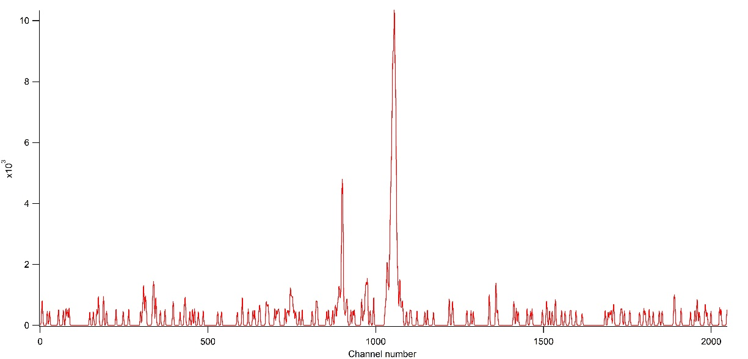

Figure 5: SX_009, 20 kV shield voltage

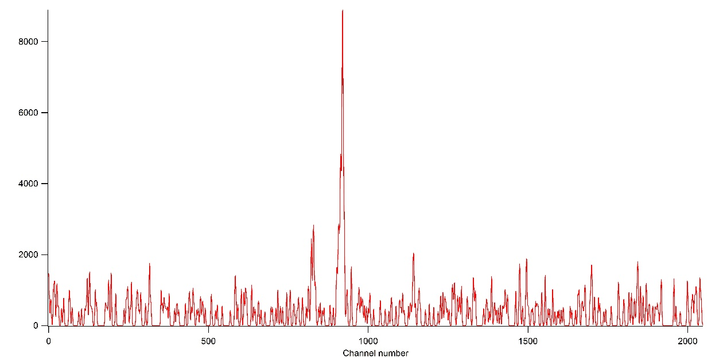

Figure 6: SX_010, 20 kV shield voltage

EBIT Run Day 3 (03/15/17):

Two CCD positions were chosen during the measurement. Firstly, the CCD was fixed at the micrometer reading of 0.995” such that the wavelength region is 4 to 20 nm. This was chosen because, the analysis of the data from last run at 2.5 keV showed that the match between theory and experiment required a space charge correction of around 450 eV. At all other energies, this correction is on the order of 150-250 eV. This deviation implied two conclusions: either the data wasn’t taken at 2.5 keV or there are other effects causing this deviation. Comparison of this measurement with the previous one should provide more information on extracting useful conclusion.

The main measurement for the Ni-like to K-like Yb was performed at the CCD position of 0.675” such that the wavelength range is around 8 to 26 nm.

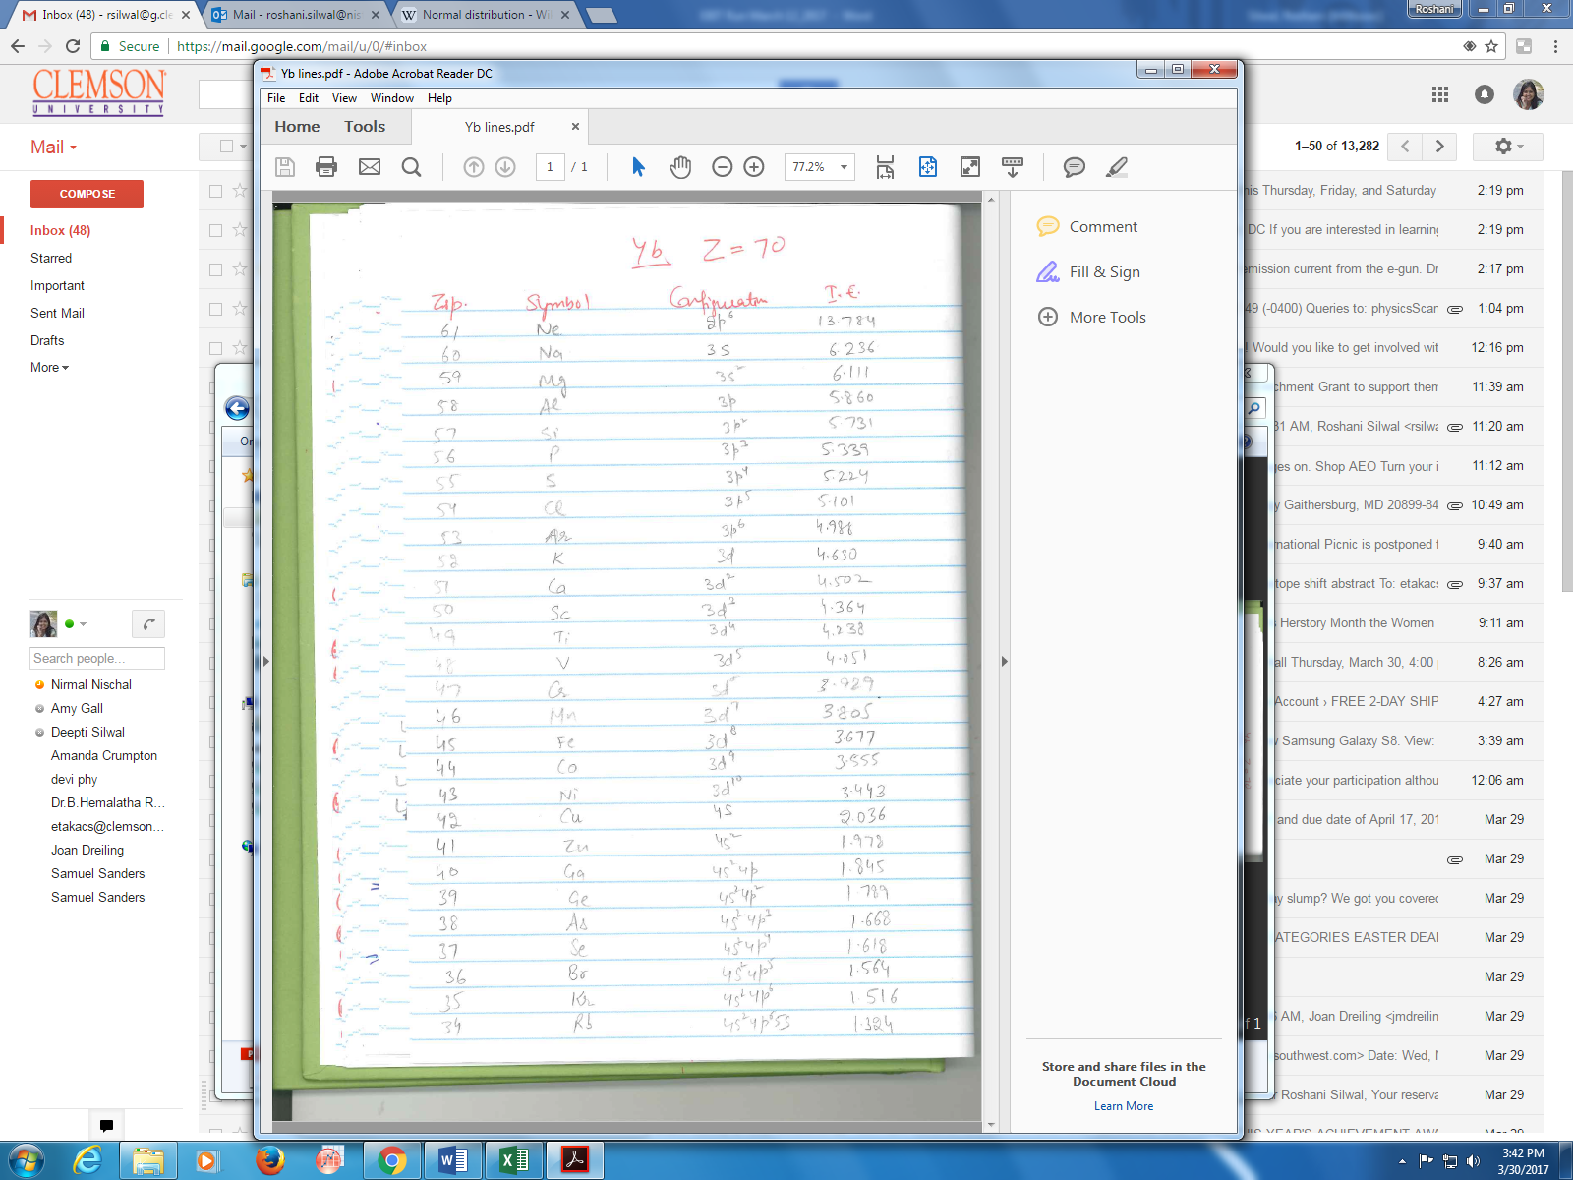

Figure 7: Ionization energies of different charge states of Yb are listed in the figure below to gather an idea of the electron beam energies during the measurement.

EUV spectra collected at different shield voltages and currents are listed in the Table 9. The data acquisition time was changed from 10 m to 15 m due to low counts. For calibration purposes, neon and background data was collected for 5 m.

Table 9:

We noticed that the MEVVA signal was 2 times weaker than during the measurement in November. Also, we were only able to attain maximum electron beam current of 125 mA compared to the usual 150 mA value. The lower MEVVA signal and beam current reduced the intensity by a factor of 5 compared to the previous measurement.

EBIT Run Day 4 (03/16/17):

We continued the measurement of Yb spectra at the CCD position of 0.675”. As the signal on day 3 was significantly lower than earlier measurements, we decided to optimize the electron beam current and the MEVVA signal. The electron beam current was optimized by changing the values of the voltages applied to the suppressor, focus, and the transition electrodes. The bucking coil and steering coil voltages were also adjusted to increase the electron beam current to nearly 145 mA. The snout current was seen to be most sensitive to the voltage applied to the transition electrode. The MEVVA signal was optimized by changing the MEVVA delay, MEVVA float voltage and the system cycle period. Table 10 shows the optimization of the signal with above mentioned parameters. Usually the signal is optimized by looking the signal of the corresponding element in the Ge detector. However, we noticed that the data in lower energy region (< 2.42 keV) were cut off in the software for some unknown reason. Due to this, we optimized the signal on the EUV detector.

The signal was approximately the same at all different settings.

Table 10:

|  |  |  |  |  |
| --- | --- | --- | --- | --- |
| Shield lab-view voltage | MEVVA float (keV) | Delay (μs) | Count | System cycle (s) |
| 3.1402 | 10 | 70 | 187 | 5 |
| 3.1402 | 10 | 76 | 200 | 5 |
| 3.1402 | 10 | 79 | 200 | 5 |
| 3.1402 | 10 | 76 | 200 | 5 |
| 3.1402 | 10 | 65 | 150 | 5 |
| 3.1402 | 10 | 85 | 130 | 5 |
| 3.1402 | 10 | 72 | 0 | 5 |
| 3.1402 | 9.95 | 72 | 200 | 5 |
| 3.1402 | 9.95 | 72 | 150-200 | 5 |
| 3.1402 | 9.85 | 72 | 174 | 5 |
| 3.1402 | 10.02 | 72 | 200 | 5 |
| 3.1088 | 10.02 | 72 | 200 | 5 |
| 3.0074 | 10.02 | 72 | 200 | 5 |
| 3.0074 | 10 | 72 | 185 | 8 |
| 3.0074 | 10 | 72 | 200 | 10 |
| 3.0074 | 10 | 72 | 200 | 5 |

Yb data collected at different electron beam energies are presented in Table 11. The Yb spectra were collected for 15 m each. Calibration spectra of 5 mins were collected for Ne, Ar and background spectra.

Table 11:

|  |  |  |  |  |  |  |  |  |  |  |  |
| --- | --- | --- | --- | --- | --- | --- | --- | --- | --- | --- | --- |
| Element | EUV | Ge | Shield Voltage (kV) | Labview setting | Gas injection pressure (Torr) | Electron beam current (mA) | Ge (min) | EUV (min) | cooking(s) | notes | EUV CCD position |
| Yb | EUV025 | X025 | 3.6 | 1.1947 | - | 145 | - | 10 | 5 |  | 0.675" |
| Yb | EUV026 | X026 | 3.75 |  |  | 145 | - | 10 | 5 |  | 0.675" |
| Yb | EUV027 | - | 5.5 |  |  | 145 | - | 10 | 5 |  | 0.675" |
| Yb | EUV028 | - | 3.9 |  |  | 145 | - | 15 | 10 |  | 0.675" |
| Yb | EUV029 | - | 4.05 |  |  | 145 | - | 15 | 10 |  | 0.675" |
| Yb | EUV030 | - | 4.2 |  |  | 145 | - | 15 | 10 |  | 0.675" |
| Bg | EUV031 | X031 | 4.82 |  |  | 145 | 3 | 5 | 10 | no dump | 0.675" |
| Yb | EUV032 | - | 4.35 |  |  | 145 | - | 15 | 10 |  | 0.675" |
| Yb | EUV033 | - | 4.5 |  |  | 145 | - | 15 | 10 |  | 0.675" |
| Yb | EUV034 | - | 4.65 |  |  | 145 | - | 15 | 10 |  | 0.675" |
| Yb | EUV035 |  | 4.8 |  |  | 145 |  | 15 | 10 |  | 0.675" |
| Bg | EUV036 |  | 3 |  |  | 81.5 |  | 5 | 5 |  | 0.675" |
| Ne | EUV037 |  | 4 |  |  | 126 |  | 5 | 5 |  | 0.675" |

Yb data collected after the LHe dewar was changed are presented in Table 12. The Yb spectra were collected for 15 m each except the one at 5.65 K which was collected for 10 m. Calibration spectra of 5 mins were collected for Ne and background spectra.

Table 12:

|  |  |  |  |  |  |  |  |  |  |  |  |
| --- | --- | --- | --- | --- | --- | --- | --- | --- | --- | --- | --- |
| Yb | EUV038 |  | 5 |  |  | 145 |  | 15 | 10 |  | 0.675" |
| Yb | EUV039 |  | 5.2 |  |  | 145 |  | 15 | 10 |  | 0.675" |
| Yb | EUV040 |  | 5.4 |  |  | 145 |  | 15 | 10 |  | 0.675" |
| Yb | EUV041 |  | 5.65 |  |  | 145 |  | 10 | 10 |  | 0.675" |
| Ne | EUV042 |  | 4 |  |  | 145 |  | 5 | 5 |  | 0.675" |
| Bg | EUV043 |  | 4.85 |  |  | 145 |  | 5 | 5 | no dump | 0.675" |

Due to the limited amount of liquid helium, we were not able to perform line identification measurements for the M-shell ion (Na-like through Ar-like). We intend to continue this measurement during the next EBIT run.

References

1. EBIT Run September 14-18, 2015